**Home Page**

**Logo of the school to the left side (Animated Gif to be left side of the page)**

**Pictures (5 Nos) Create – Liberate – Transform**

**Home Page** : Below the pictures :

**THIS IS MY CALL – THIS IS OUR CALL to immerse in human reality and to be a transforming presence in our context today.**

May we be guided by the light of compassion, the warmth of empathy, and the wisdom of experience. Let us approach each patient with reverence, recognizing the sacredness of their journey and the privilege of being invited into their lives during moments of vulnerability.

~~Compassionate Caregivers: We are the epitome of compassion, providing care that goes beyond medical treatments to comfort and support patients in their times of need.~~

**About Us**

The Rino Simoneti Memorial (R.S.M) School of Nursing was established in the year 2006 by Rt. Rev. Dr. George Mamlassery, the Bishop of Tura, Meghalaya, and entrusted with the North East Society of the sisters of the Holy Cross, Menzingen, Switzerland.

The Holy Cross Sisters have been engaged in health care ministry and education globally for the past 200 years. The School of Nursing is attached to the Holy Cross Hospital, Tura, established in the year 1993.

The R.S.M School of Nursing aims to prepare professionally qualified nurses to meet the health care needs of the people of the locality, in the Christian spirit of service.

R.S.M School of Nursing is recognized by the Indian as well as the Meghalaya Nursing Councils for the revised General Nursing & Midwifery Course of three years.

At RSM School of Nursing, we believe in the transformative power of education and the profound impact nurses make in healthcare. More than an institution, our school is a community of passionate educators, dedicated students, and visionary leaders shaping the future of healthcare.

Established with a commitment to excellence, RSM has a rich heritage of producing exceptional nursing professionals. Our graduates are not just skilled practitioners but compassionate caregivers, innovative thinkers, and advocates for health equity.

Our cutting edge curriculum is designed to prepare students for the dynamic challenges of modern healthcare. Through a blend of theoretical knowledge and ~~hands-on~~ clinical practice, our students develop the critical thinking, clinical skills, and ethical foundation needed to excel in their careers.

**Mission**

Rooted in the Gospel values of love, compassion, and justice, an institution of integrity, strives to educate students to deliver holistic ~~and~~ excellence in health care that addresses the physical, emotional, and spiritual needs of individuals and communities.

**Vision**

To be an institution of excellence providing value-oriented education, rendering ~~service~~ marked with quality, integrity and commitment in the service of humankind.

**Core values**

* Compassion and Caring
* Service to ~~Others~~ the needy
* Excellence in Education
* Ethical Practices
* Holistic Approach to Care
* Social Justice and its Advocacy
* Community and Collaboration
* Embracing the universality

**The motto of R.S.M School of Nursing is :**

**“THAT THEY MAY HAVE LIFE IN ITS FULLNESS” (JOHN 10:10).**

**Philosophy**

* We the management and staff of R.S.M School of Nursing, believe that God created all human beings in God’s own image and likeness. Therefore, we respect LIFE as sacred and precious from the moment of conception till its natural end.
* We believe that health is the right of every individual and that we are called to promote health and prevent and cure illness wherever possible.
* We believe that modern nursing education should keep abreast of the research and developments in the medical field.
* ~~We believe that modern nursing education should keep pace with the scientific progress in the medical sciences science field.~~
* We recognize that a substantial portion of learning in nursing is acquired ~~in the clinical field~~ through clinical practice.
* We believe that nursing education should provide for ~~that~~ the holistic development of students and also ~~train~~ prepare them to be providers of holistic health care to the ~~people~~ needy.
* We believe that as responsible citizens of the country, the nurses can contribute ~~greatly~~ significantly, towards building up of a healthy nation.

**Objectives**

On successful completion of the General Nursing Course of three years at RSM, a student being transformed to a meticulous nursing professional is expected to:

* have the professional competence in planning and providing safe nursing care to patients suffering from ~~various types of illness~~ any ailment, applying relevant knowledge from the biological and behavioural sciences.
* have the knowledge and competence to provide effective health education for preventing disease, promoting ~~health~~ and restoring health.
* observe the moral and ethical values in ~~her~~ personal and professional life.
* ~~co-operate~~ collaborate ~~effectively~~ constructively with ~~other members of~~ the health team in ~~the~~ institutional as well as community health care services.
* ~~demonstrate~~ exhibit basic skills in managing a hospital ward, as well as a community health unit.
* ~~render service~~ serve ~~to fellow beings~~ with tenderness, concern and respect, and commit ~~themselves~~ to provide ~~the best quality~~ outstanding care.
* ~~have the~~ develop professional competence to be employed as staff nurses at primary, secondary or tertiary health care centres in the country or even health care centres and hospitals abroad.

**Our Founders**

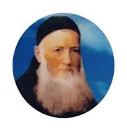

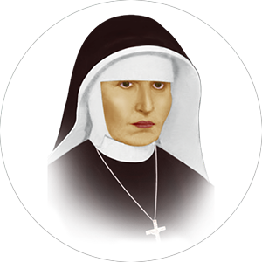

1808 - 1865

1822 - 1863

We are known as ‘Sisters of the Holy Cross Menzingen.’  As women of Hope we strive to be a ‘Transforming Presence’ and bear witness to Jesus Christ in the reality where we live and work.

As Sisters of the Holy Cross we owe a great debt of gratitude to our Founder Fr. Theodosius Florentini, a Franciscan Capuchin Friar (OFM) (1808-1865) and Mother Bernarda Heimgartner our Foundress (1822-1863). Our Congregation came to existence on 16 October 1844 at Menzingen in Switzerland. The Congregation, in its readiness to be of service to the society, took up health care, education, care of orphans, care of the women in need and various other pastoral and social works extending through various locations.

Today as promoters of life we are called to reach out to where life is endangered. We collaborate and network with parishes, social leaders, church Institutions, health care organisations, governments and non-governmental organisations for the cause, where we promote justice, mercy and equality.

**Message from Principal’s desk**

*The best way to find yourself is to lose yourself in the service of others*

*Mahatma Gandhi*

RSM School of Nursing is a distinguished institution rooted in the rich tradition of Catholic values. We are dedicated to foster excellence in nursing education, research, and clinical practice. Our commitment to provide supportive and innovative learning environment ensures that our students are equipped with the knowledge, skills, and values inevitable to surpass in the dynamic field of health care. We embrace the values of compassion, service, and excellence, inspired by the teachings of Jesus the great teacher. As the Principal of this institution, I am honored to nurture both the minds and spirits of our students. Our rigorous academic programs, empowers our students to make a meaningful difference in the lives of those they care for. We believe that healthcare is not merely a profession but a sacred calling, and we are committed to instilling in our students a deep sense of responsibility even towards the most vulnerable members of our society. Together, let us continue to uphold the values of compassion and excellence in nursing education and in our clinical field.

**Our Benefactors**

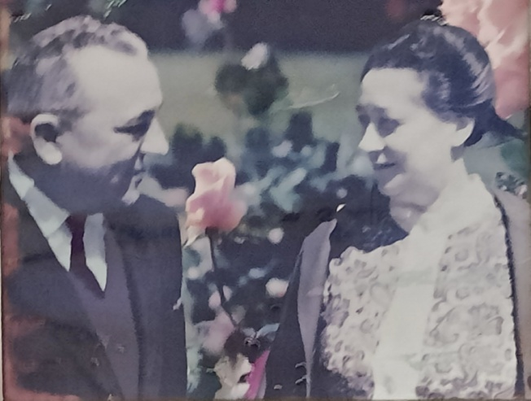

Mr & Mrs. Rino Simoneti, Italy

**Facilities**

**Hospital**

**Holy Cross Hospital, Walbakgre, Tura**

The hospital started functioning in the year 1993 under the auspices of Holy Cross Congregation. It is the fulfilment of a great dream of Most Rev. George Mamlassery, the Bishop of Tura Meghalaya. The inadequate health care facilities existing in Garo Hills had invoked in his grace a missionary zeal to construct a 100-bed hospital. The hospital was inaugurated by the Parliamentarian Shri Purno A Sangma. Holy cross hospital is the most sought after medical institution in West Garo Hills.

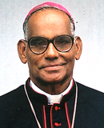

Rt. Rev. George Mamlassery, Bishop Emeritus, Tura

The hospital provides comprehensive health care services in the field of Paediatrics, Gynecology, Neonatology, General Medicine and Surgery, Ultrasound scanning, X-Ray, ECG and Echocardiography and also renders medical assistance to Cardiology, Urology, Paedriatric and general surgery, Orthopaedic and Laparoscopic surgeries

**Diagnosis Services**

* Imaging services
* X-Ray
* Ultrasound
* ECG
* Laparoscopic services
* Clinical pathology
* Clinical Biochemistry
* Haematology
* Microbiology
* Serology

**Library**

The school has a well established Library, where we foster an environment of learning, exploration, and growth for our students. Our library has computers and WIFI connections and it is a hub of academic support, and a gateway to the vast world of healthcare knowledge.

**Hostel Accommodation**

The course is strictly residential. All students will be provided hostel accommodation in the school campus.

As you step into our hostel, you'll find a warm and inclusive environment where students from diverse backgrounds come together in pursuit of their nursing education. Our rooms are designed to provide comfort and privacy, ensuring that you have a peaceful haven to rest and recharge after a day of rigorous study and clinical practice. Here, lifelong friendships are forged, where students support and uplift each other through the challenges of academic life. Our common areas are vibrant hubs of activity, where you can unwind, socialize, and engage in meaningful conversations with your peers. As part of a Catholic institution, we offer opportunities for prayer, Holy Mass and spiritual guidance, providing a supportive environment for students to nurture their faith and deepen their connection to something greater than themselves.

**Admission**

**Course**

GNM Nursing

**Admission criteria**

1. Educational qualification: 10+2 with Minimum 40% marks in English and 50%in other subject from any recognized board. However Science is preferable.
2. Age: Minimum age for admission is 17yrs (as on 31st December of that year).
3. Ability to follow class room instruction in English.
4. Basic Computer course and Spoken English Certificate
5. Single females of good health, good moral character and aptitude for nursing.

**Selection and Admission**

* Duly filled application form, together with self-attested true copies of the documents mentioned therein, should reach the office on or before the stipulated date.
* Candidates eligible for admission will be called for a written test and a personal interview after initial screening of applications
* Selection list is finalised based on the pass in the entrance test and personal interview conducted by the management and clearance in the subsequent medical check up. The candidate shall bear the expenses towards any special investigation, if found necessary.

**Preliminary Course and Confirmation of Admission**

The provisionally selected candidates have to undergo a course of three months which will conclude with an examination. Candidates who exhibit the intellectual and practical ability and right aptitude for Nursing will have their admission confirmed. Those who fail in the examination will have to clear the examination or leave the Institution.

The students who gains admission for the course are expected to demonstrate diligence in their studies, both theoretical and practical, and to complete the course successfully in due time.

**News and Events**

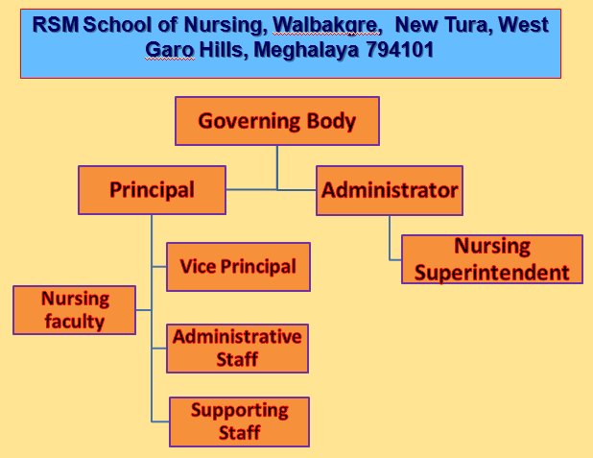

**Contact**

Principal, Rino Simonetti Memorial (RSM) School of Nursing, Holy Cross Hospital, Tura 794101

Phone :07005594107, 9378001174

Email: [rsmchooltura@gmail.com](mailto:rsmchooltura@gmail.com)